NAME : PAREENITA A.SHIRSATH PRN : 221101062 T.E.A.I.&.D.S. ROLL.NO : 57

**DAV EXPERIMENT 8**

import pandas as pd

import matplotlib.pyplot as plt

df = pd.read_csv("/content/Salary_Data.csv")

plt.figure(figsize=(8, 6))

plt.plot(df["YearsExperience"], df["Salary"], marker='o', color='blue', linestyle='-')

plt.title('Relationship between Years of Experience and Salary')

plt.xlabel('Years of Experience')

plt.ylabel('Salary')

plt.grid(True)

plt.show()

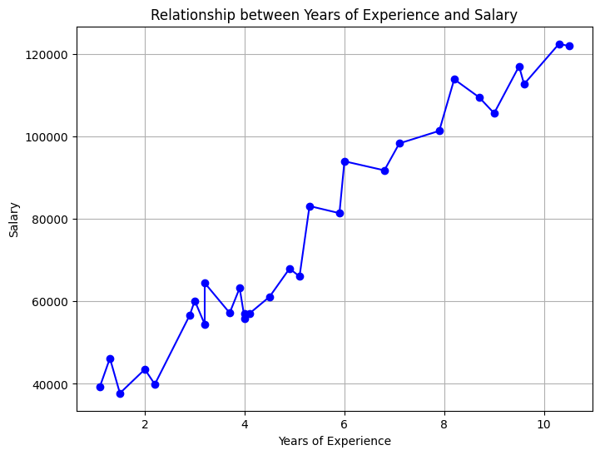

import pandas as pd

import plotly.express as px

df = pd.read_csv("/content/Salary_Data.csv")

# Create a line plot using Plotly

fig = px.line(df, x='YearsExperience', y='Salary', title='Relationship between Years of Experience and Salary')

fig.update_traces(marker=dict(color='blue', size=10),

                  line=dict(color='blue', width=2))

fig.update_layout(xaxis_title='Years of Experience', yaxis_title='Salary')

fig.show()

